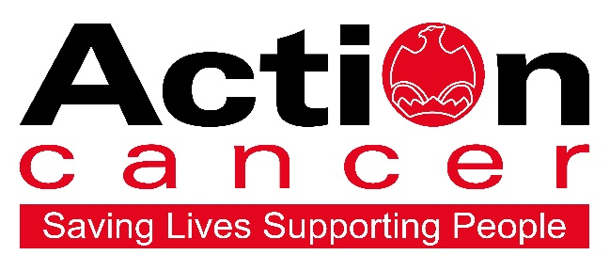



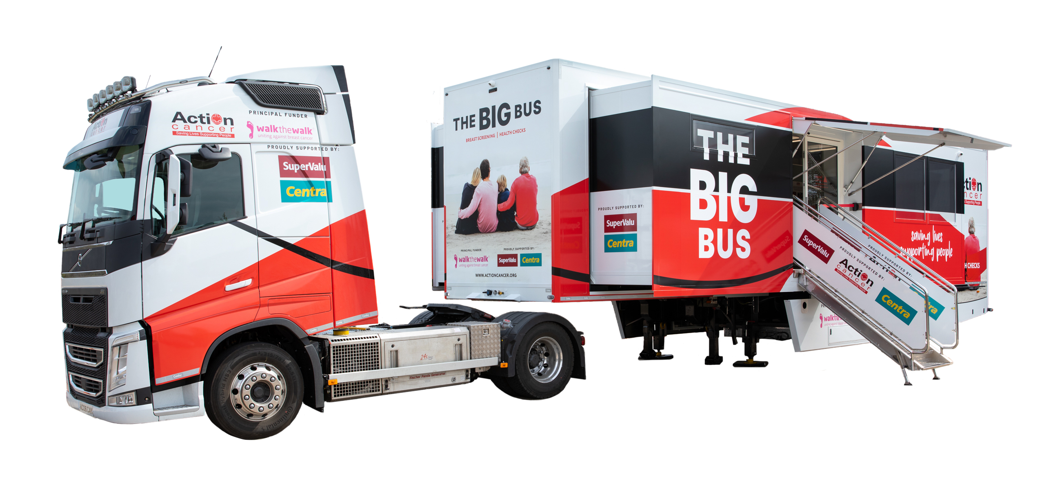

Proudly supported by




BIG BUS Protocols

Contents

Breast Screening………...........................2
M.O.T Health Check.................................3
Appointment Promotion……………….......4
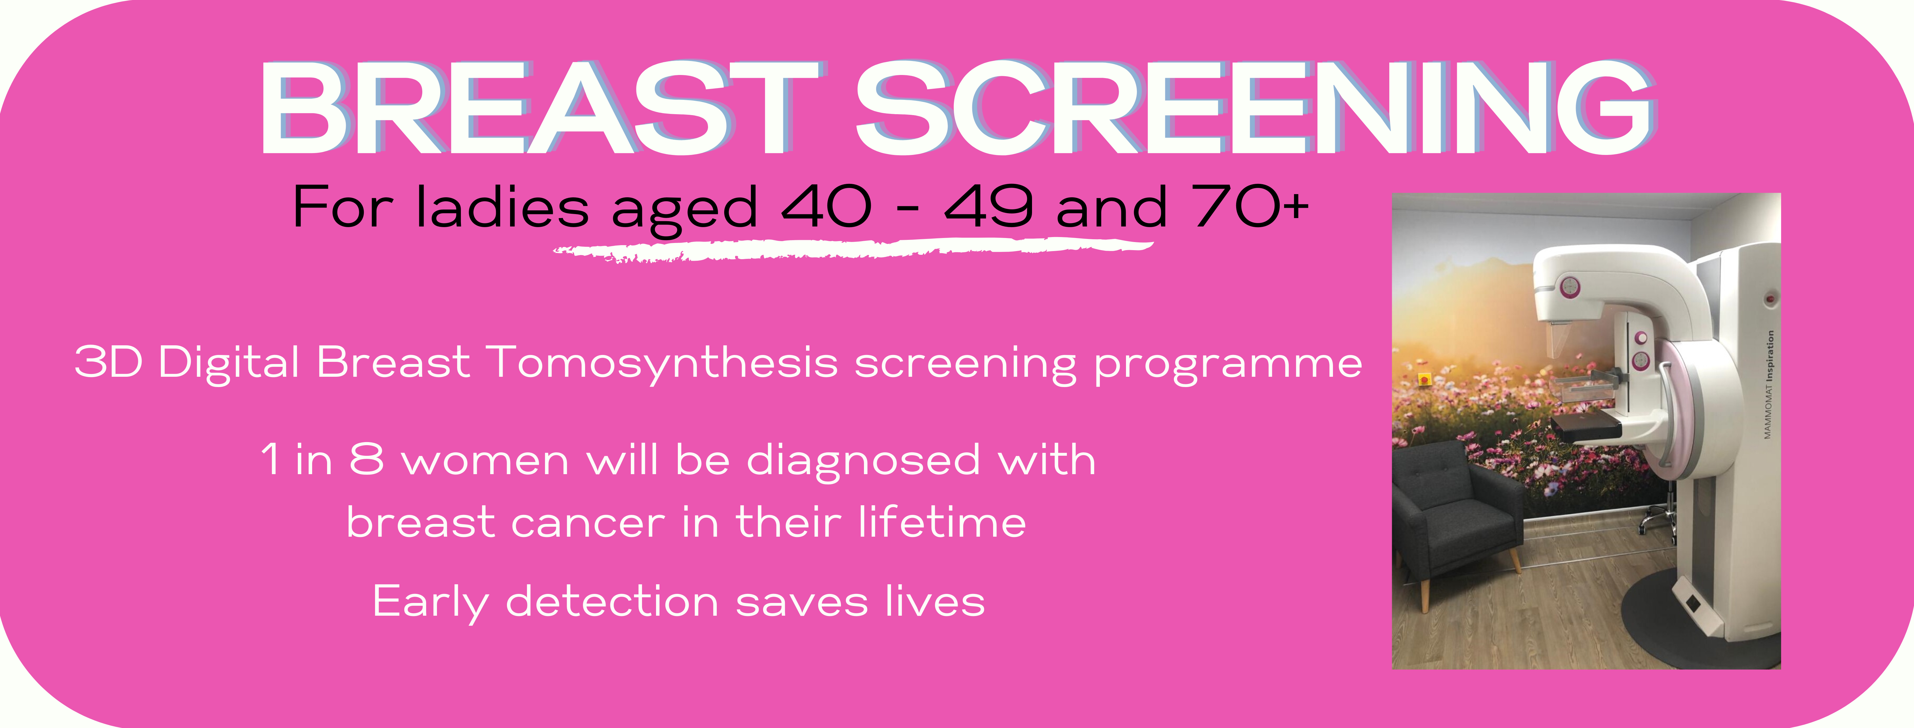

Breast Screenings – 21 appointments per day

1 in 8 women will be diagnosed with breast cancer. While this is a frightening statistic, detecting breast cancer early makes it a very treatable diagnosis. Using the latest digital mammography technology, we are able to see cancers millimetres in size and before women have developed symptoms or a lump. All women over 40 should be having regular mammograms.

Action Cancer’s Big Bus offers this free service to women aged 40-49 & 70+ every 2 years (The NHS screening program will call all women aged 50-70 every 3 years).

Appointments last approximately 15 minutes and results are processed within 3 weeks. Clients and their GP will both receive the results by post. If further assessment is required, Action Cancer will liaise with the client and their nearest symptomatic Breast Clinic to arrange this.

Who is eligible for an appointment?
- Women aged 40-49 or 70 plus who are not showing any symptoms.
Who is not eligible for an appointment?
- Women with a breast symptom or concern - they should see their GP.
- Women who have been pregnant or breast-feeding within the last 6 months.
- Women who have had a previous mammogram within last 2 years.
- Women aged 50-69 (they should avail of the free NHS screening service).
- After the mammogram:
- The mammogram will be sent to Action Cancer House for reporting by Consultant Radiologists or specialist Radiographers. The results process takes up to 3 weeks.
- A results letter will be sent to the client and their GP.
- If further investigation is required, Action Cancer will arrange for the client to be seen at their nearest symptomatic Breast Clinic.

Testimony from Service User

Kate Comiskey lives near Markethill with her husband Patrick. She has three sons, David, Andrew and Patrick.

“It was over Breast Cancer Awareness Month when I read in the newspaper that the Big Bus was coming to my home-town. Being proactive about my health and somewhat curious about the service, I booked a screening appointment onboard.
As a result, I was referred to a specialist breast clinic for further investigation. I didn’t think much of it as I was fit and healthy and was at the time training for a marathon.

When we got the news that it was cancer, we were absolutely shell-shocked. I had six rounds of chemotherapy and then a course of radiotherapy. Receiving a cancer diagnosis is a shocking blow to any individual. I felt let down by my body. I had, I felt, done everything in my power to defend myself from cancer through my active and healthy lifestyle. I never considered the idea of being personally afflicted by this illness.

I will be eternally grateful for the breast screening service that Action Cancer offers and for detecting the cancer so early. I have slowly but surely started to re-integrate myself into my old lifestyle; I am looking forward to becoming more like the old Kate Comiskey again.”
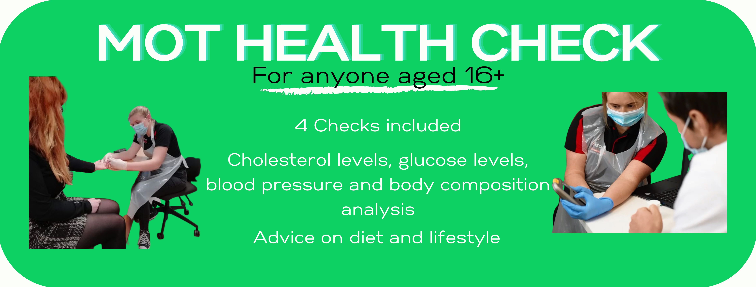

MOT Health Checks - 11 appointments per day

Health check appointments are for anyone aged 16 and over. They aim to increase awareness of the importance of early detection and to provide a picture of your current health and the areas you may wish to make changes in.

Each appointment will last 20 minutes and comprises 4 tests as outlined below, as well as a discussion on lifestyle choices, such as diet and exercise. These health checks do not provide a cancer diagnosis.

The four health check tests are:

Cholesterol Testing*
The cholesterol measurement involves obtaining a single sample of blood from the individual’s finger using a sterile needle. It is important to have your cholesterol monitored as high cholesterol increases your risk of serious health conditions such as heart attack and stroke.

Glucose Testing*
The glucose measurement requires a single sample of blood from the individual’s finger using a sterile needle. The glucose measurement is used to indicate the risk of Diabetes.
Blood pressure and pulse rate*
Blood pressure measures how strongly blood presses against the walls of your arteries as it is pumped around the body by your heart. If this pressure is too high it puts a strain on your arteries and your heart which makes it more likely that you will suffer a heart attack, stroke or kidney disease.
Body Composition analysis
- Carried out in the form of bioelectrical impedance analysis (BIA). These professional scales measure weight, body fat %, fat mass, muscle mass, total body water %, metabolic age, basal metabolic rate (BMR), visceral fat (fat which gathers around internal organs) and body mass index (BMI). *. For more accurate results it is recommended that you should not do heavy exercise or eat a large meal in the 3hrs before this test.

Please note the following:

- A three hour fast is necessary before the cholesterol and glucose tests.
- Cholesterol and glucose tests cannot be carried out if the client is suffering from a bleeding disorder or on blood thinning medication (e.g. Warfarin).
- Body Composition Scales cannot used if the client is pregnant or has any internally implanted medical devices (e.g. pacemaker).
- If results from any of these* tests are outside the healthy ranges, we will write to the client’s GP to make them aware.
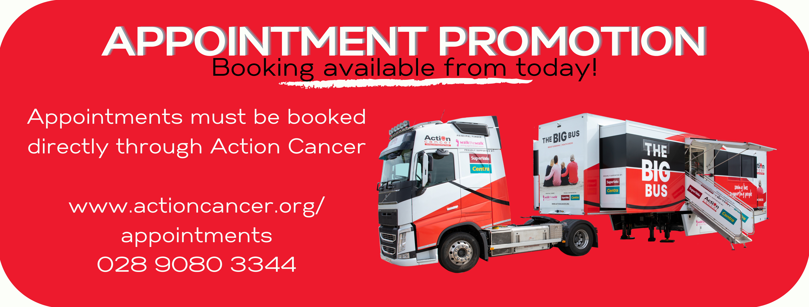

The BIG BUS - Appointments Promotion

The date and location for your BIG BUS visit has been finalised; you now need to spread the word!

Promoting the BIG BUS visit

You need to take an active role in promoting the BIG BUS. Action Cancer will assist you as much as possible with this.

Poster

A BIG BUS poster has been included in your confirmation email. It includes a space for you to compete your visit details. You can print & display these locally or upload to your social media. If you need printed A4 or A3 copies, please request these from us.

Information
Your confirmation email contains some wording relating specifically to your visit, which you can copy and paste into any advertising literature you create. You can also use wording or graphics from this document.

Website & Social Media
If appointments for your visit are made available to the public, Action Cancer will list the location on the BIG BUS section of our website. In the event that Screening and/or Health Check appointments are slow to fill, we will highlight the availability on our social media.

How to make an appointment

This is a quick and easy process, done directly by individuals through Action Cancer. There are two ways to book.


Visit our Online Booking System
Clients can book, cancel or reschedule appointments online at http://appointments.actioncancer.org If your BIG BUS visit is Private, they will need to input the unique reference code, provided in your confirmation email.


Call the Appointment Phone-line
Clients can call us on 028 9080 3344 and select Option 5 from 9am-4.45pm Monday to Friday. If your BIG BUS visit is Private, they will need to quote the unique reference code, provided in your confirmation email.

