MENOPAUSE AND ME
This factsheet aims to inform and educate line managers to better support their staff when going through this time and provide information for employees on managing menopause symptoms.
Business in the Community promotes a whole person approach to wellbeing that includes mental, social, physical and financial aspects.
It is important for staff members going through the menopause that this experience is recognised by line managers; and that they are supported through this, sometimes challenging, period of their lives. Educating staff about the menopause can empower individuals to make better decisions about their own physical and mental health with the support of an informed and understanding line manager.

What is the menopause?
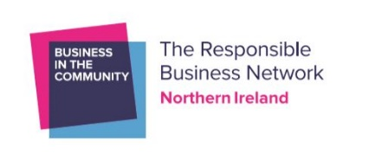
The menopause is a transition, it is not a one-off happening but something that can last from 4 – 8 years. It is part of life and not an illness – although it can lead to complications in some cases. The menopause effects women physically, mentally and emotionally.
But the good news is that we are talking about it and raising awareness and that helps immensely – sharing our experiences talking about our experiences eliminates fear and empowers us to take charge of our health.
We first start to feel the effects of the menopause in our early 40’s. it takes us longer to recover, sleep becomes an issue, low mood, etc. Then, as it progresses, more and more symptoms occur.

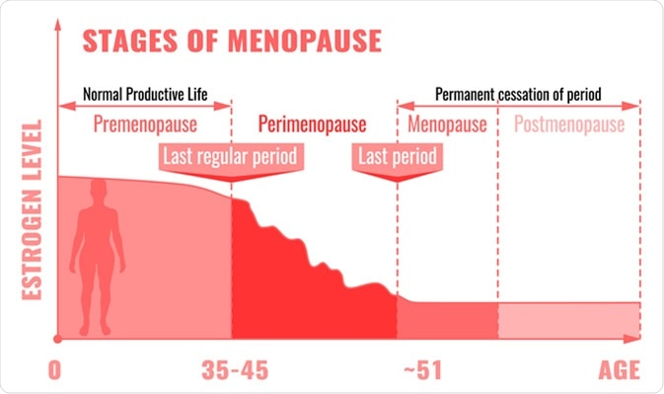
Our hormones play a very important part in our lives this is not just about our reproductive system but how hormones impact our entire mental and physical systems. And these levels do not decline in an orderly fashion, they go and up down and this can have a devastating impact on us and those around us.
Hormones
Oestrogen is the main hormone that contributes to the symptoms of the menopause.
Oestrogen is not only important for the health and maintenance of our reproductive systems but is vital for cognitive health, bone health, our cardiovascular system and bladder health. As we near menopause our hormone levels start to fluctuate, and this gives raise to the symptoms that we experience.
Menopause Symptoms
The menopause impacts women physically and mentally. This symptom tracker is an important tool when diagnosing the menopause (as fluctuating hormones are hard to measure).
The most common symptoms are hot flushes, night sweats, insomnia, bladder, and psychological issues. According to the TUC Menopause Report 29% of women have felt that their symptoms have directly impacted on their self-confidence and their ability to do their job. Using this Tracker can help you understand what your symptoms are, how often they are occurring and is there a pattern to them. This is a useful thing to do for yourself and for when you visit the GP as having an accurate list of symptoms will help with your diagnosis and treatment plan.
Issues and Long-Term Health Implications
Urinary Tract Infections this can lead to women having to take time off from work and it can be very painful and distressing.
Psychological impact can be very profound and worrying to individuals, Sudden onset Depression or Anxiety. Low self-esteem and confidence can be very debilitating and can be one of the reasons that women reduced their hours, leave work, etc.

Menopause Symptom Tracker

Hot flushes |  | Itchy skin
Night sweats |  | Fatigue
Aching joints |  | Anxiety
UTI |  | Disrupted sleep
Bladder issues (going more) |  | Hair loss
Irregular periods |  | Hair growth
Digestive problems (bloating, constipation, diarrhoea, indigestion etc) |  | Memory lapses
Mood swings |  | Weight gain
Vaginal dryness |  | Dizziness
Decreased libido |  | Stress incontinence
Headaches |  | Brittle nails
Breast soreness |  | Allergies
Electric shocks |  | Irregular heartbeat
Muscle tension |  | Body odour/excessive sweating
Gum problems |  | Irritability
Tingling extremities |  | Depression
Panic attacks |  | Osteoporosis
Insomnia

HRT – what you need to know?
Hormone Replacement Therapy (HRT) addresses the underlying cause of your symptoms and safeguards against cardiovascular disease, it can also make you feel better. Check out the British Menopause Society for up to date research about HRT.
What is HRT?
HRT is a treatment that relives your menopause symptoms by replacing the oestrogen your body stops producing during your menopause. All forms of HRT contain oestrogen which works to ease symptoms such as hot flushes, mood changes and urinary symptoms. It comes in 2 types: Oestrogen only and Combined HRT (containing a synthetic version of progesterone).
Which type you are prescribed depends on a number of factors and this decision is taken with your Doctor. How you take HRT varies and depends on personal choice and what is the best fit.

Types of HRT

Method | How it works | Pros | Cons
Oral oestrogen tablet | Taken daily | - Easy to remember | - Less reliable absorption  - May not be suitable if overweight or T” Diabetes
Oestrogen skin patch | Change weekly | - Easy to use  - Continue physical activities  - Constant level delivered  - Can use more than 1 patch | - Skin sensitivity
Oestrogen gel | Rubbed on arms or legs | - Easy to alter dose  - Can be used with patches  - If still having period can ease PMT | - Skin sensitivity  - In early menopause may need higher doses
Oestrogen implant | Under the skin | - Releases oestrogen over several months  - Can be useful to women who do not absorb oestrogen well | - Can lead to fluctuating hormones
Topical vaginal oestrogen | Cream, tablet or ring to ease dryness | - Does not have the same risks as HRT – restores oestrogen to vagina & surrounding areas  - Can be used alongside hrt | - Does not improve other symptoms of menopause

There are a variety of ways to take HRT, therefore you need to research the options and have a frank discussion with GP or preferable a Menopause Specialist (Doctor or Nurse) so that you can make the decision that is best for your body and lifestyle.
What to say to the Doctor?
- For most people, their first appointment will be with their GP (TIP: if possible book a double appointment) also ask if they have someone who specialises in the menopause in the surgery.
- Use the symptom tracker and go through each symptom you have and discuss the severity, length, and frequency of symptoms. This is important as it will help the medical professional with their diagnosis.
- List any medications you are taking including herbal medicines or supplements.
- Ask for a referral to the NHS Menopause Clinic based in The Mater Hospital in Belfast (unfortunately there is a waiting list at present). There are also private Menopause Clinics in N. Ireland. These Menopause clinics are staffed by doctors, nurses and counsellors who have specialised in Menopause treatment.
- Ask questions and you should be offered another appointment in 3 months under NICE guidelines to ascertain if the treatment is working.
Complementary & Alternatives Medicines
These preparations are not usually available on the NHS so you will probably need to see a private practitioner. It is important to tell your doctor or Menopause Practitioner if you are trying herbal medicines bought over the counter or by a herbalist.

Most popular Herbal Medicines

Medicine | What is it? | What is it used for? | NICE verdict
St john’s wort | Plant | - Best known as a remedy for depression but it taken by some women for hot flushes | - Nice guidelines note that this can treat hot flushes, but the ingredients can vary. And this compound can interfere with other drugs.
Black cohosh | Herb | - For hot flushes & night sweats
Isoflavones | A type of phytoestrogens which are compounds similar to oestrogen we produce. Found in red clover, soy, flax seeds, lentils and oats. | - Hot flushes & night sweats | - Again ingredients and effects can vary among products. It can also interact with other drugs.

Alternative Treatments
Acupuncture
Acupuncture is a traditional Chinese Medicine practice of inserting fine needles at specific points in the body. This method restores the body’s ‘Qi’ or energy flow. The method generally practiced here stimulates the nervous system and is mainly used to treat musculoskeletal pain. NICE recommends acupuncture for migraines and chronic headaches; some women have reported that acupuncture has helped with their menopausal symptoms.
Aromatherapy
Is a complementary therapy that uses oils extracted from plants to promote relaxation and wellbeing. Oils can be added to water and burned to release the smell, added to carrier oils, and massaged directly onto skin or put into bath water. Using oils can relieve stress and promote wellbeing do speak to an aromatherapist for more information.
We all deserve access to good advice & support. And it is important that we talk openly about the menopause and provide support for others. We will all go through this and it doesn’t have to be awful.
More information
www.thebms.org.uk
www.daisynetwork.org
www.mymenopausedocter.co.uk
www.bitcni.org.uk/programmes/the-menopause-me-digital-toolkit/

For more information, visit www.bitcni.org.uk or email info@bitcni.org.uk

