PSYCHOLOGICAL IMPACT OF THE MENOPAUSE
This factsheet outlines steps to help you understand the psychological impact of the menopause.
The psychological impact of the menopause can be a very frightening time for a lot of women, this is because the symptoms can be overwhelming and cause a lot of distress.
Hormones play a very important part in this process, both oestrogen and progesterone are not only responsible for our reproductive system the play an integral part in our brain function & development.
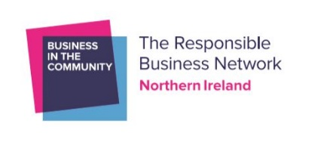
This oestrogen is responsible for the following:
- The Increases serotonin and serotonin receptors
- Increases production and effects of endorphins
- Maintains body temperature

Progesterone is responsible for:
- Enhances cognitive ability
- Helps you fall & stay asleep
- Eases anxiety
Therefore, when these hormones start to fluctuate and decline it has a direct psychological impact.

Menopause Psychological Symptoms Tracker

Mood swings
Anxiety and sudden onset anxiety
Irritability
Insomnia
Loss of libido
Loss of concentration
Memory issues
Depression

Why are serotonin and endorphins important?
Serotonin is a chemical nerve cell s produce and it send signals between your nerve cells. Serotonin impacts every part of your body, from your emotions to your motor skills and it is considered a natural mood stabilizer. It’s the chemical that helps with eating, sleeping and digesting. When your serotonin levels are normal you feel:
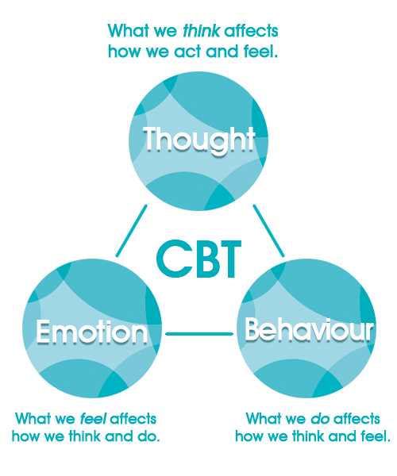
- Happier
- Calmer
- More focussed
- Less anxious
- More emotionally stable

Natural serotonin boosters:
- Exposure to sunlight or light therapy (NI Libraries have Light Boxes)
- Regular exercise
- Healthy diet - some serotonin boosting foods: eggs, cheese, turkey, nuts, salmon, tofu, and pineapple.
- Meditation: mindfulness can help relieve stress and promote a positive outlook on life

Endorphins are tiny neurochemicals released in our bodies that are natural pain killers and boost our pleasure receptors in our brains. Endorphins are released in response to stress and pain and are also released in other activities, like eating, exercise, and sex.

Natural endorphin boosters:
- Regular Exercise
- Creativity: writing, drawing, baking, it is the process of creating that gives you the boost.
- Sex
- Food: dark chocolate, spicy food, red wine
- Dance
- Meditate
- Aromatherapy

CBT – what is it, and how does it help?
Cognitive Behaviour Therapy (CBT) is a talking therapy that can help you manage your problems by changing the way you think and behave. It is most commonly used for anxiety & depression. CBT focuses on challenging and changing negative thought and behaviours; it helps improve emotional regulation and the development of personal coping strategies.

Negative thoughts
We have over 70,000 thoughts a day and it is impossible to act upon them all, but the negative thought rises to the top and stay there. So, how do we stop them? One way is to ‘reframe’ the thought and to think of your anxiety, depression or anger as external beings that are separate to you. For example, if you are anxious, then you begin to see anxiety as separate from you. Anxiety is a big chaotic messy bully who stands behind you and questions you and makes you doubt yourself.
Start to recognise the thoughts and identify what is the problem that is causing them. Visualise your anxiety, journal it and reflect on what has happened.
Reframing thoughts
- Thoughts/beliefs I notice: When I did that presentation today, I had a hot flush, and everyone thought I was an idiot
- Reframed thoughts and beliefs
- My anxiety is telling me that everyone thought I was an idiot, but I had worked hard, and the presentation was well received and having a hot flush during a presentation on the Menopause was inspired!
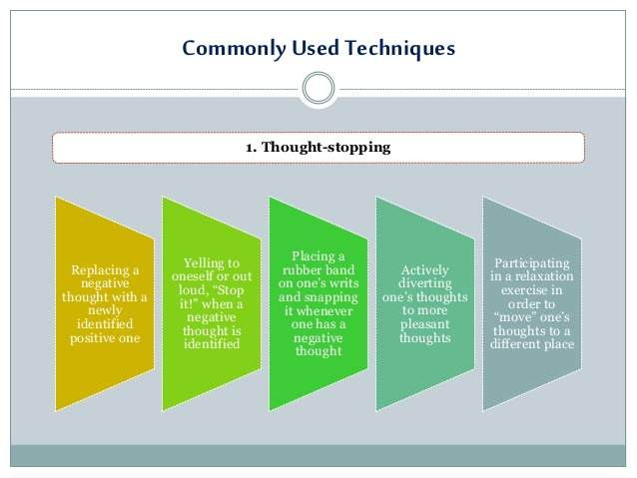

Meditation and Mindfulness
Mindfulness is derived from Buddhist traditions of meditation based on Zen and Tibetan practices. These techniques have been used for 1000 of years. The practice that we call Mindfulness was rediscovered and repackaged for ‘western society’ by Jon Kabat-Zinn in 1979 founded the Mindfulness Based Stress Reduction (MBSR) at the University of Massachusetts to treat the chronically ill, this programme became the blueprint for secular Mindfulness programmes that are available in schools, business, hospitals, etc.
How to do it?
Mindfulness – that it is the art of paying attention. Being in the moment, being conscious of your emotions, feelings, physical surroundings. The practice of Mindfulness is based on breathing, it is as simple and complicated as that.
Focus your attention on your breathing. And breathe. A key element in mindfulness is to establish a deep breathing routine. This can help alleviate blood pressure and heart rate. This is known as conscious breathing.
Sit in a comfortable position with feet planted firmly on the ground. Close your eyes. Take a deep breath in for the count of 4, hold for a count of 3, and release on the count of 4. Continue this for at least 3 rounds and then return breathing to normal.
Being able to bring awareness to your breath calms the body and the mind. And prepares you to meditate. Breathing like this can be done numerous times in the day.
Complete a body scan
Silencing the ‘monkey mind’ it is difficult to completely silence your inner critic and stop obtrusive thoughts but with practice this does become easier. Letting go! Imagine that your thoughts are cars going past on a busy road, acknowledge them and let it go. The ‘monkey’ mind has been silenced, the inner critic has left, and it is these moments that creativity develops and flourishes.
Affirmations at the end of practice:
- I am enough
- I am worthy
- I completely and fully accept myself as I am.
For more information and details of free or part-funded classes, visit the following websites:
www.aware-ni.org
www.mindingyourhead.info/stress-control-classes
www.gov.uk/government/organisations/health-protection-agency
EFT – Emotional Freedom Techniques
EFT or Tapping is an alternative form of therapy for anxiety and depression. EFT or Tapping is a form of psychological acupressure. It was developed by Gary Craig in the 1990’s and it is used worldwide as a form of therapy to treat:
- Phobias
- Anxiety
- Depression
- PTSD
- Weight loss
The process involves tapping on specific parts of the body, mainly on the head and face, in a particular sequence. While, doing this the person focuses on the issue they want to treat.
Tapping involves the body’s energy meridian points, which are a concept in Chinese Medicine. Proponents believe them to be areas of the body through which energy flows.
In this theory, blocks or imbalances in the flow of energy lead to ill health. According to EFT advocates, tapping on these meridian points with the fingertips restores the balance of energy to resolve physical and emotional issues.
It can also work in a similar way to mindfulness, as it can draw a person’s attention to their body and breathing. It may serve as a mental distraction from the issues that are causing anxiety or stress.

EFT Tapping in 5 steps
- Identify the issue you want to address, e.g. I feel anxious
- Test the initial intensity – using the SUE Scale rank the intensity of how you feel on a scale of 0 – 10, with 10 being the most intense. This will help evaluate the effectiveness of the Tapping.
- The set-up: using a set-up phrase helps us to focus on the issue. This phrase should be used at the beginning when Tapping on the karate chop point. This point is at the centre of the fleshy part of the outer hand. The set-up phrase should acknowledge the issue and convey self-acceptance in spite of it. The set-up phrase should be: “Even though I have this anxiety I completely and fully accept myself as I am.”
- The sequence: during this phase, the individual follows a sequence of Tapping points while repeating the set-up phrase.
- Test the intensity again: using the SUE scale check the intensity of the original feeling or issue. Repeat again if necessary.

These are just some of the techniques and tools that have proven useful to lots of women to help them regulate and manage their emotions and it is about finding what is right for you and taking control of your emotions and building your own self-care routine.

More information
www.menopausematters.co.uk
www.menopausecafe.net/
https://henpicked.net/
www.nhs.uk/conditions/menopause

For more information, visit www.bitcni.org.uk or email info@bitcni.org.uk

